Lecture 4
CO1: Apply the knowledge about the concepts of probability and statistics for the computer applications.
CO3: Apply the knowledge about basic ideas of statistics including measures of central tendency, correlation and regression.

Measures of central tendency
Mode
Look at the following example: A company produces readymade shirts of different sizes. The company kept record of its sale for one week which is given below:
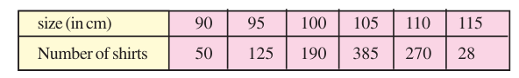
From the table, we see that the sales of shirts of size 105 cm is maximum. So, the company will go ahead producing this size in the largest number. Here, 105 is nothing but the mode of the data. Mode is also one of the measures of central tendency.
The observation that occurs most frequently in the data is called mode of the data.
In other words, the observation with maximum frequency is called mode of the data. The readymade garments and shoe industries etc, make use of this measure of central tendency. Based on mode of the demand data, these industries decide which size of the product should be produced in large numbers to meet the market demand.
Mode of Raw Data
In case of raw data, it is easy to pick up mode by just looking at the data. Let us consider the following example:
Example 1: The number of goals scored by a football team in 12 matches are:
1, 2 Example 1:, 2, 3, 1, 2, 2, 4, 5, 3, 3, 4. What is the modal score?
Solution: Just by looking at the data, we find the frequency of 2 is 4 and is more than the frequency of all other scores. So, mode of the data is 2, or modal score is 2.
Example 2: Find the mode of the data: 9, 6, 8, 9, 10, 7, 12, 15, 22, 15
Solution: Arranging the data in increasing order, we have
6, 7, 8, 9, 9, 10, 12, 15, 15, 22
We find that the both the observations 9 and 15 have the same maximum frequency 2. So, both are the modes of the data.
Remarks:
1. In this lesson, we will take up the data having a single mode only.
2. In the data, if each observation has the same frequency, then we say that the data does not have a mode.

Mode of Ungrouped Data
Let us illustrate finding of the mode of ungrouped data through an example
Example 1: Find the mode of the following data:
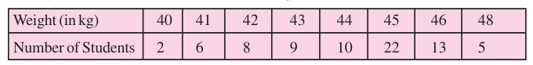
Solution: From the table, we see that the weight 45 kg has maximum frequency 22 which means that maximum number of students have their weight 45 kg. So, the mode is 45 kg or the modal weight is 45 kg.
Practice Questions:
- Find the mode of the data: 5, 10, 3, 7, 2, 9, 6, 2, 11, 2
- The number of TV sets in each of 15 households are found as given below: 2, 2, 4, 2, 1, 1, 1, 2, 1, 1, 3, 3, 1, 3, 0 What is the mode of this data?
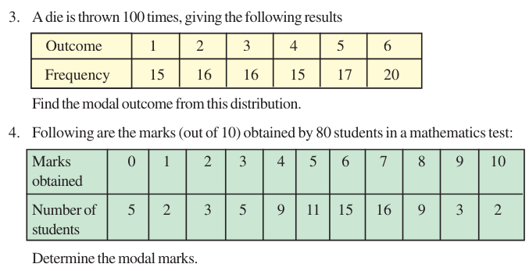

Advantages & Disadvantages of Mode
Advantages
- From a simple frequency distribution, mode can be obtained only by inspection. Also, for a simple series with a small number of observations, mode can often be determined without any calculation.
- It is unaffected by the presence of extreme values.
- Unlike A. M., it can be calculated from frequency distributions, with open-end classes. In fact, if the modal class and its two adjoining classes together with their class frequencies are available, mode can be determined, provided it is known that all classes are of equal width.
Disadvantages
- Mode has no significance unless a large number of observations is available.
- It is a peculiar measure of central tendency. For any given set of observations, is always possible to find the values of A.M., G.M. H.M. or median. But it mode may not exist. When all values occur with equal frequency, there is no mode. On the other hand if two or more values have the same maximum frequency, there is more than one mode (A distribution is called unimodal, bimodal or multimodal, when it has one, two or more than two modes).
- From a grouped frequency distribution, it is difficult to locate the mode accurately. An approximate value of mode is obtained by the formula only when all classes are of equal width, and the class with the largest frequency is preceded and followed by two other classes. Even then, if class frequencies do not show any gradual tendency to maximum concentration in a class, or the largest frequency occurs in two or more classes, the formula is inapplicable.
- For the calculation of mode, the data must be arranged in the form of a frequency distribution.
- Mode cannot be treated algebraically.
TEXT BOOKS
- T1 = H. K Dass, Higher Engineering Mathematics, S. Chand Publishers,3rd revised edition.2014.
- T2 = B.S. Grewal, Higher Engineering Mathematics, Khanna Publishers,42th ed.2013, New Delhi.
- T3= N. P. Bali and Manish Goyal, A textbook of engineering Mathematics, Laxmi Publications, Reprint 2008.

REFERENCE BOOKS
- R1=R. K. Jain and S. R. K. Lyenger, Advanced Engineering Mathematics ,3rd Edition Narosa Publishing House ,2004,New Delhi.
- R2 =B. V. Ramana Advanced Engineering Mathematics, McGrawHill, July2006, New Delhi.
- S.P.Gupta,StatisticalMethods,S.Chand&Sons,2017,NewDelhi,ISBN9789351610281Insiders’Guide

Video Lecture :
https://www.youtube.com/watch?v=2N7na6aBvpk

